1. Create Chart between Measure Names and Measure Values. Add filter to Measure Names

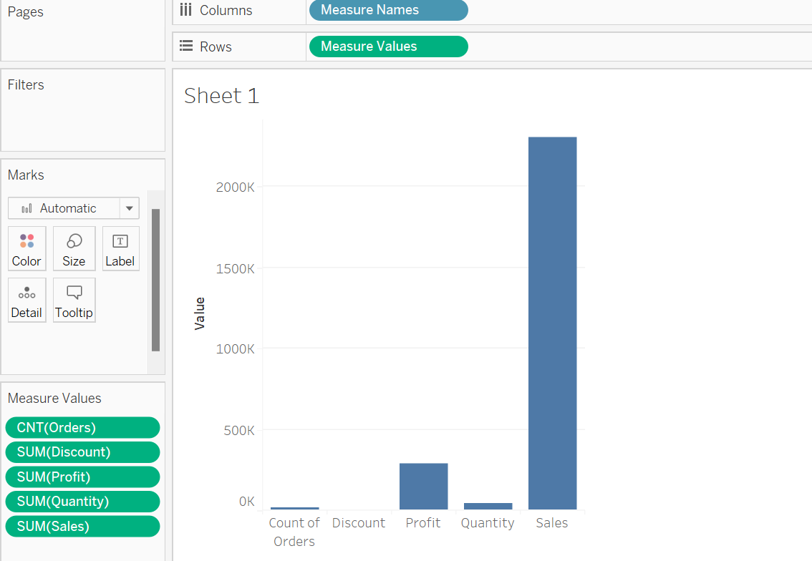

2. create a chart for the total profit on different years along with the profit earned by

months

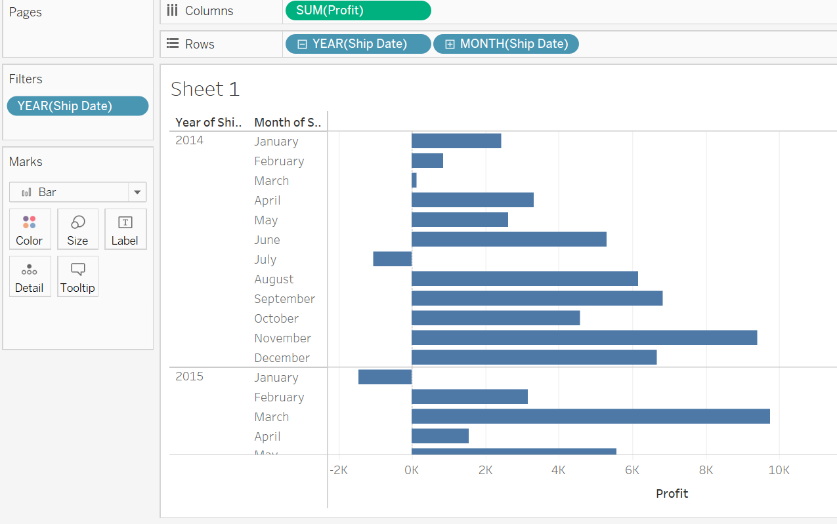

3. Create chart for the total profit on different years along with the profit earned by

months on the x-axis.

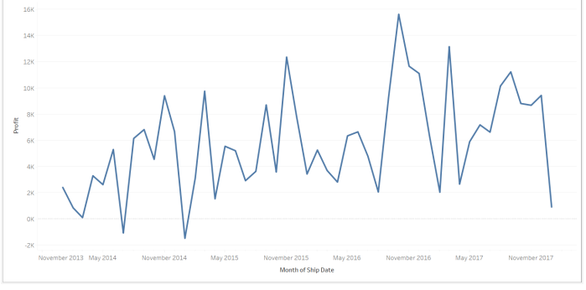

4. Create a text table for the Avg (Sales) for each subcategory using Sample Superstore?

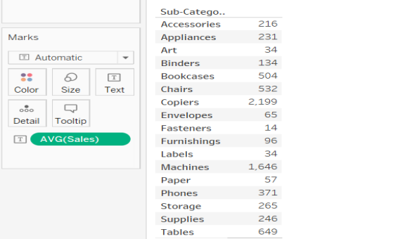

5. List which Sub Category is got Avg (Sale) more than $1000? -Sample Superstore

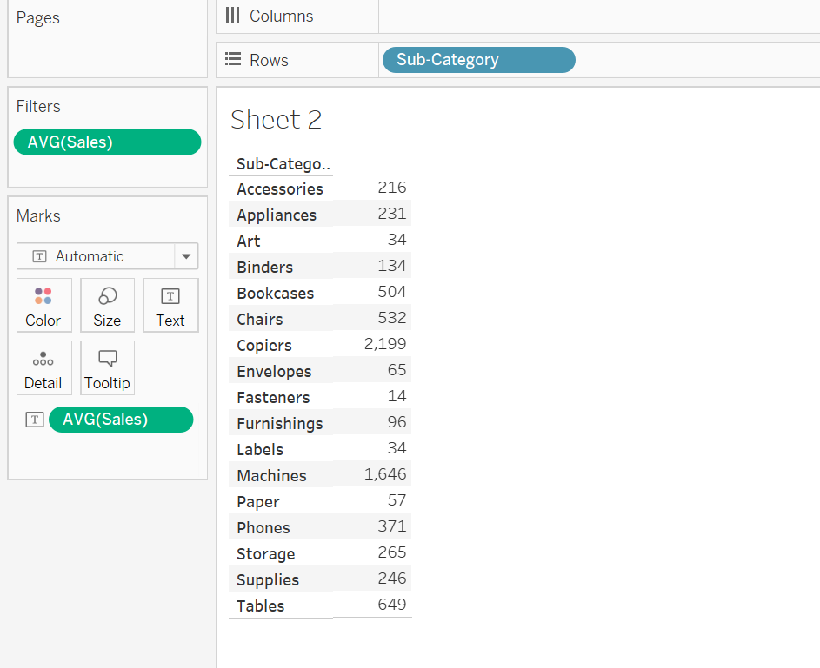

6. Create a Highlight table for the States for the Order Date Year whose highlighting is

done based on Sum of profits -Sample Superstore

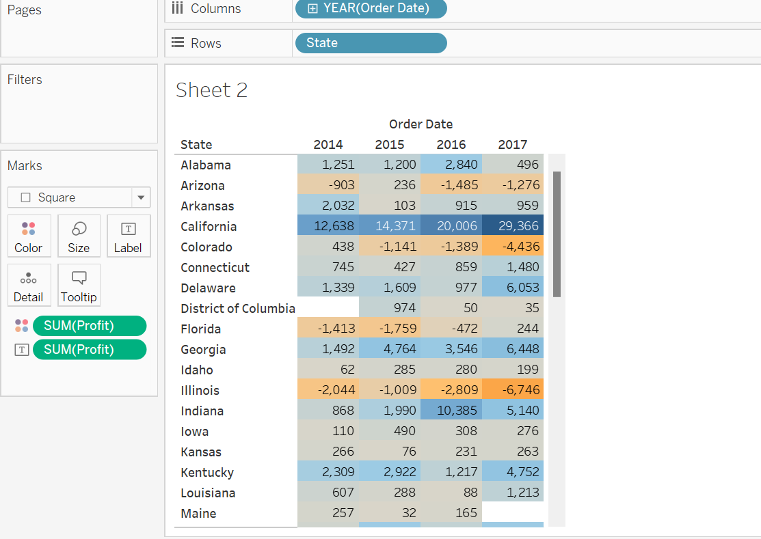

7. Which customer is having maximum returns of sales in the year 2011? -Global

Superstore

